Creating NIC Bonding

in VirtualBox
Take a snapshot
Attached to Bridged Adapter Network

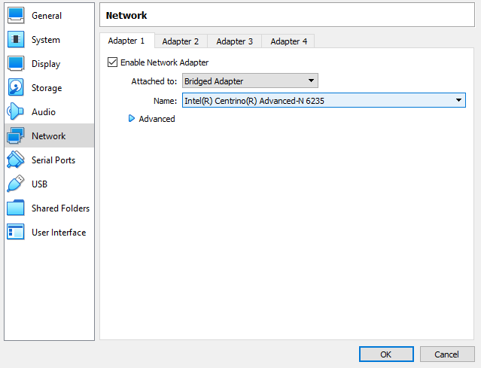

Enable Adapter 2 with Bridged Adapter Network

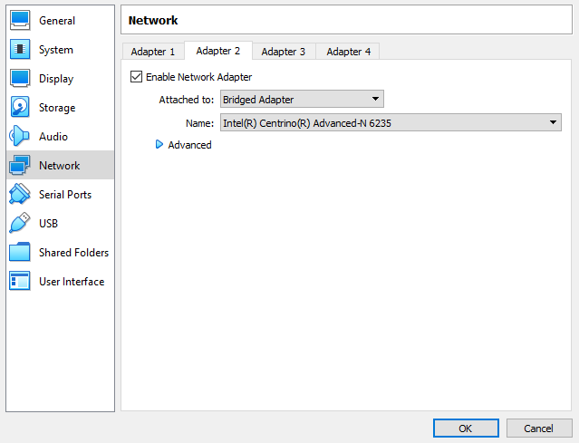

in VMware
Take a snapshot
Attached to Bridged Network Adapter

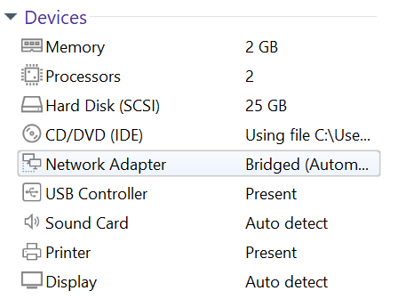

Open the Hardware tab and click Add

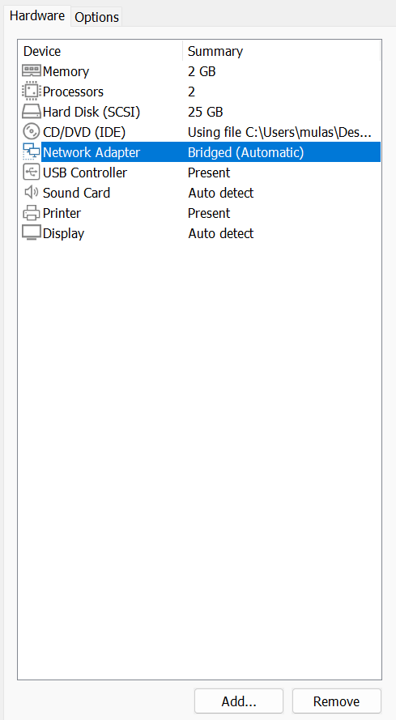

Select Network Adapter and click Finish then click OK

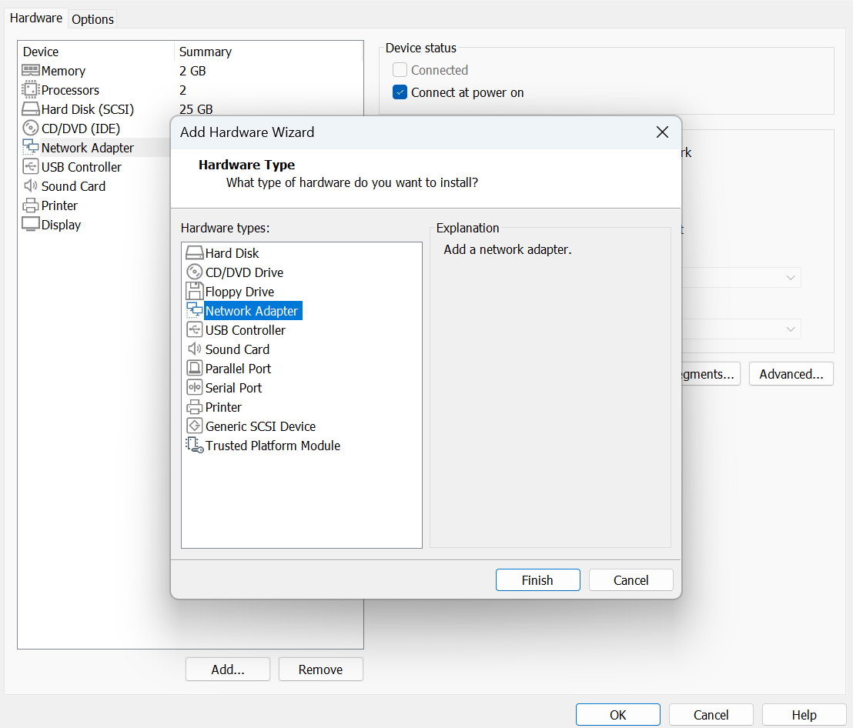

Find the Network Adapter 2

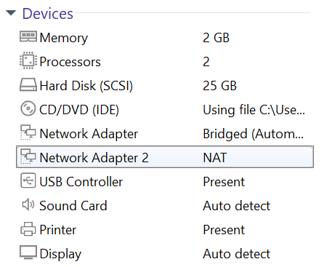

Attached to Bridged Network Adapter 2

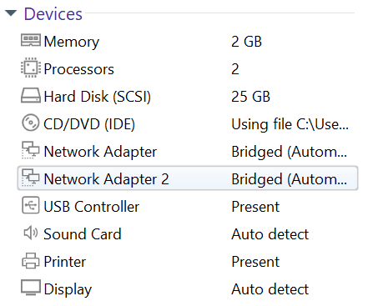

Become root
ifconfig | more
modinfo bonding | more
(Find the Bonding Driver in description below snap, if not install bonding driver)

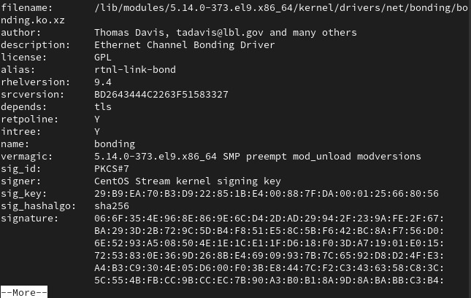

vi /etc/sysconfig/network-scripts/ifcfg-bond0
DEVICE=bond0
TYPE=Bond
NAME=bond0
BONDING_MASTER=yes
BOOTPROTO=none
ONBOOT=yes
IPADDR=192.168.237.50 (Find through ifconfig utility)
NETMASK=255.255.255.0
GATEWAY=192.168.237.201 (Find through netstat -rnv or route -n)
BONDING_OPTS=”mode=5 miimon=100”

vi /etc/sysconfig/network-scripts/ifcfg-enp0s3
TYPE=Ethernet
BOOTPROTO=none
DEVICE=enp0s3
ONBOOT=yes
HWADDR=08:00:27:8b:b0:c6 (MAC from the ifconfig utility)
MASTER=bond0
SLAVE=yes

vi /etc/sysconfig/network-scripts/ifcfg-enp0s8
TYPE=Ethernet
BOOTPROTO=none
DEVICE=enp0s8
ONBOOT=yes
HWADDR=08:00:27:88:16:bb (MAC from the ifconfig utility)
MASTER=bond0
SLAVE=yes

systemctl restart NetworkManager
ifconfig | more
cat /proc/net/bonding/bond0

